Experiment 2.3
Determination and plotting of Electric field (E) and Electric flux density (D) in a sphere full of charges with varying radius

Code File Name: Exp2_3_LinearChargedSphere_ED.m
Code
clc;
rho0 = 1e-6;
epsilon = 8.854e-12;
R = 1;
r = linspace(0, R, 100);
D = (rho0 .* r.^2) / 4;
E = D / epsilon;
subplot(1,2,1);
plot(r,D,'LineWidth',2);
xlabel("Radius (m)");
ylabel("Electric Flux Density (D)");
title("Linear Density: D vs Radius");
subplot(1,2,2);
plot(r,E,'LineWidth',2);
xlabel("Radius (m)");
ylabel("Electric Field (E)");
title("Linear Density: E vs Radius");
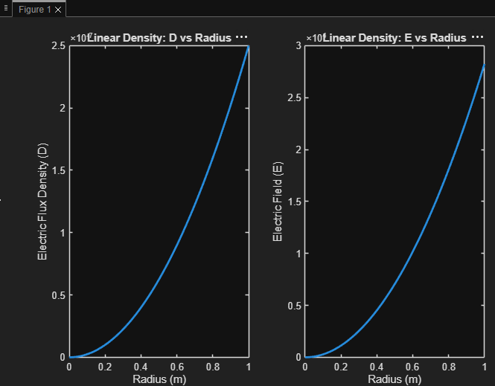
Output Graph

